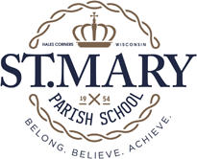

St. Mary Parish School Committee Meeting
August 4, 2020

- Opening Prayer

- Approval of meeting minutes from May 11, 2020

- Principal Report
- School Reopening Plan
- How will virtual learning be implemented?
- Feedback from families?

- Old Business

- New Business
  - How will specials be handled?
  - Will extended care be offered to parents?

- Parish Update

- Next Meeting: September 8, 6 p.m.

Mission Statement: Celebrating spiritual growth while providing academic excellence in a Christ-centered environment.

